**Exercise 2: Verifying Interactions**

**Scenario:**

You need to ensure that a method is called with specific arguments. **Steps:**

1. Create a mock object.

2. Call the method with specific arguments.

3. Verify the interaction.

**ExternalApi.java**

package mockito.example;

public interface ExternalApi {

    String getData();

    String getData(String p);

}

**MyService.java**

package mockito.example;

public class MyService {

    private ExternalApi api;

    public MyService(ExternalApi api) {

        this.api = api;

    }

    public String fetchData() {

        return api.getData();

    }

    public String fetchData(String giri) {

        return api.getData(giri);

    }

}

**MyServiceTest.java**

package mockito.example;

import static org.mockito.Mockito.*;

import org.junit.jupiter.api.Test;

import org.mockito.Mockito;

import static org.junit.jupiter.api.Assertions.assertEquals;

public class MyServiceTest {

     @Test

    public void testVerifyInteraction() {

        ExternalApi mockApi = Mockito.mock(ExternalApi.class);

        MyService service = new MyService(mockApi);

        service.fetchData("Girish"); //since step-2 asked to call method with args passing one arg string

        verify(mockApi).getData("Girish");

    }

}

**Output:**

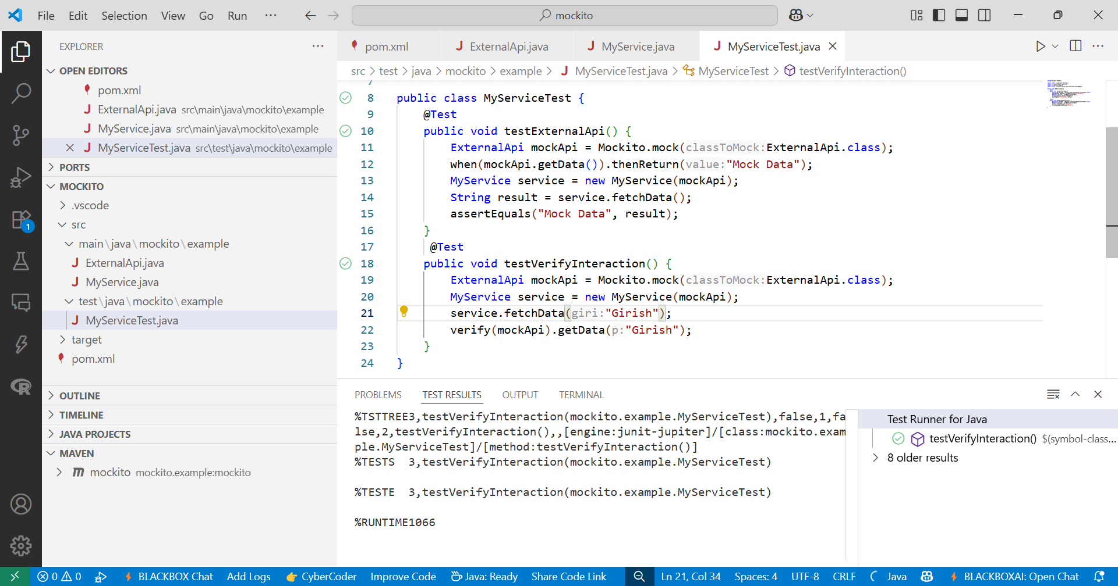

Fig-1:Tested method with one argument